**Alpha Beta Result**

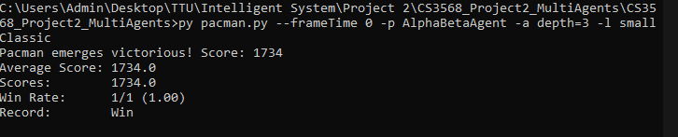

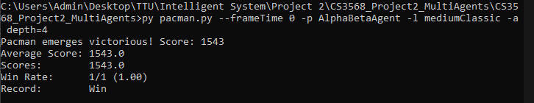

**Min Max Result**

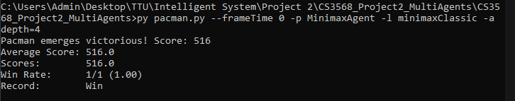

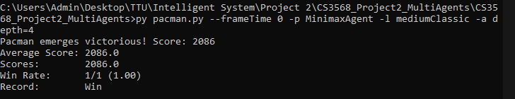

**Reflex Agent Result**

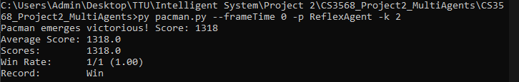

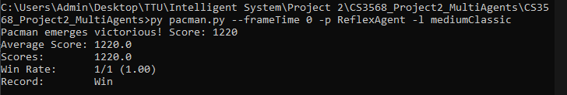

**Expectimax Result**

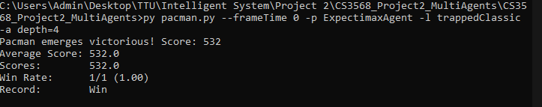

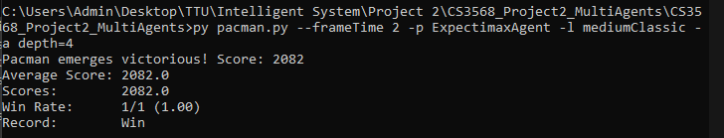

**Better Evaluation Function**

